CHAPTER 3: SYSTEM ANALYSIS AND DESIGN
3.1 Introduction
This chapter gets into the nitty-gritty of how MedAssistAI is actually built. I'll walk you through the development approach I'm using, whether the project is actually doable, how I collected and analyzed requirements, what the system needs to do, and how I've designed both the logical structure and the physical pieces. The whole chapter builds toward showing how the dual-AI setup—with Fadhili AI as the main engine and Google Gemini API as the backup—comes together into a working system that actually helps Kenyans stick to their medication routines.
3.2 System Development Methodology
3.2.1 What Methodology I'm Using and Why
I've chosen to use Design Science Research (DSR) as my overall research framework. This approach is perfect for projects like this because it focuses on building and testing something new—in this case, MedAssistAI itself. DSR isn't just about coding; it's about creating an innovation and figuring out if it actually solves the problem it's meant to solve.
Within DSR, I'm using an Agile-Scrum hybrid approach with two-week sprints. This means I break the work into short cycles, each delivering something concrete. Here's why this combination works:
Flexibility matters. Building something new means I'll learn things along the way. Maybe users tell me something different from what I assumed, or maybe a technical approach turns out to be harder than expected. Agile lets me adjust course without throwing everything away.
Getting feedback early and often. Every two weeks, I'll show what I've built to my supervisor and, where possible, to potential users. Their input shapes what comes next. This keeps me from building something nobody actually wants.
Catching problems early. When you test as you go, you find issues when they're small and cheap to fix, not at the end when everything is tangled together.
Having something working quickly. By the end of the first few sprints, I'll have a basic but functional prototype. Then I just keep making it better.
3.2.2 The Six Phases of Development
Here's how the eight months break down into concrete phases:
Phase 1: Analysis (Weeks 1-4, December)
This is where I get really clear on what I'm building. I'll dig deeper into the literature, finalize my requirements based on talking with healthcare providers and patients, and set up my development environment. By the end, I'll have a detailed requirements document and a project plan with prioritized features.
Phase 2: Design (Weeks 5-8, January)
Now I figure out how everything fits together. I'll design the system architecture, sketch out the database schema, create user interface mockups, and plan exactly how the dual-AI integration will work. The deliverables here are architecture diagrams, UI mockups, and a technical design document.
Phase 3: Core Development (Weeks 9-14, February)
This is when I actually start coding the essential pieces: user registration and login, adding and tracking medications, a basic reminder engine, and the database connections. By the end of this phase, I'll have a working prototype with the core features in place.
Phase 4: AI Integration (Weeks 15-20, March)
Now comes the interesting part—building Fadhili AI. I'll develop the custom AI plugin, fine-tune it on Kenyan medical terminology and patient interaction patterns, connect it to Google Gemini API as a backup, and build the failover mechanism that switches between them seamlessly. This phase also includes adding the smart features: personalized reminders and drug interaction checking.
Phase 5: Local Features and Integration (Weeks 21-24, April)
This phase makes MedAssistAI truly Kenyan. I'll add M-Pesa payment reminders, connect to Africa's Talking API for SMS, implement Swahili language support throughout the interface, and refine the user experience based on early feedback.
Phase 6: Testing and Documentation (Weeks 25-32, May)
The final stretch is all about quality. I'll test everything thoroughly—unit tests, integration tests, security tests, usability tests with real users. I'll fix bugs, optimize performance, and write all the documentation: user manuals in both English and Swahili, technical specifications, and guidelines for anyone who wants to build on this work later.
3.2.3 The Tools I'm Using
Component | Technology | Why I Chose This
Frontend | React.js | It's component-based, so I can reuse UI pieces. Huge community means help is easy to find. Works great on phones, which matters because most users will access this on mobile.
Backend | Node.js with Express | Using JavaScript everywhere—frontend and backend—simplifies things. Node is fast and perfect for API-driven applications like this one.
Database | MongoDB | It stores data as flexible JSON-like documents, which fits perfectly with my JavaScript stack (Node.js backend, React frontend). I don't need to wrestle with rigid table schemas—patient data can vary, and MongoDB handles that gracefully. It's also free, open-source, and scales well.
Primary AI | Fadhili AI (custom-built) | This is the heart of my innovation. By building my own AI rather than just using someone else's API, I can make it truly understand Kenya—Swahili, local medical terms, our cultural patterns around medication.
Secondary AI | Google Gemini API | If Fadhili AI goes down or gets slow, Gemini steps in. It's reliable, well-documented, and has a generous free tier for development.
SMS Integration | Africa's Talking API | They're a local company that actually covers Kenya well. Supports both SMS and USSD, and their API is developer-friendly.
Version Control | Git/GitHub | Industry standard. Free for students, which is great for my budget.
Testing | Jest, Postman | Jest handles unit testing on the frontend and backend; Postman tests API endpoints. Together, they give me comprehensive coverage.
3.3 Feasibility Study
Before diving into building, I needed to honestly assess whether this project is actually doable. I looked at it from several angles.
3.3.1 Economic Feasibility: Can I Afford This?
As a student, budget is a real constraint. Here's the honest breakdown:
What I already have or can get free:
- Development laptop: Already owned
- All software tools: Open-source or free tiers
- Internet: Student bundles (KES 6,000 for eight months)
What I need to pay for (estimates):
Item | Estimated Cost (KES) | Notes
Africa's Talking SMS credits | 2,000 - 5,000 | For testing, roughly 2,000 messages
Google Gemini API credits | 0 - 3,000 | Free tier covers most student needs
Domain name (optional) | 1,000 - 2,000 | Can use free subdomain instead
Cloud hosting | 0 - 5,000 | Free tier available during development
Printing & binding | 3,000 - 5,000 | For submission copies
Transport for interviews | 2,000 - 5,000 | To meet potential users in Nairobi area
Contingency (10-15%) | 3,000 - 5,000 | For unexpected costs
Total estimated: KES 25,000 - 45,000
That's realistic for a final-year IT project in a Kenyan university. Most of the work uses free tools, and I'm not paying myself a salary since it's my project.
What about sustainability? If this were to actually launch, monthly operational costs would be around KES 15,500 for 1,000 users (hosting, API calls, SMS). With a freemium model—basic features free, premium at KES 200/month—I'd need about 78 premium users to break even. That's doable.
3.3.2 Technical Feasibility: Can I Actually Build This?
The hardware: I have a personal laptop with 16GB RAM and an i5 processor—more than enough for development.
The software stack: Everything I need is open-source or has free tiers. React, Node.js, PostgreSQL—all free. Africa's Talking and Google Gemini have free tiers for students and small projects.
The hard part: Building Fadhili AI from scratch is ambitious for an undergraduate project. I'm being realistic about it—I'll start with a simpler rule-based system, then add machine learning progressively. The dual-AI setup with Gemini as backup means that even if Fadhili isn't perfect on day one, the system still works.
The risks and how I'll handle them:
Challenge | How I'll Handle It
Custom AI is complex | Start simple, add complexity gradually. The first version doesn't need to be perfect.
API rate limits | Cache responses aggressively. Queue requests during peak times.
Unreliable internet | SMS fallback is the answer. Plus offline data storage on the device.
Data security | Build encryption and access controls from day one, not as an afterthought.
Bottom line: This is technically challenging but absolutely doable. The dual-AI design actually reduces risk because I always have a backup.
3.3.3 Operational Feasibility: Will People Actually Use This?
Are users ready for this? Most Kenyans have mobile phones. Many use M-Pesa daily. While not everyone is tech-savvy, I'm designing the interface to be simple—big buttons, clear labels, Swahili option. People don't need to be experts.
Will it fit into existing workflows? Clinics can just recommend the system to patients—they don't need to change how they operate. Pharmacies get payment reminders integrated with what they already use. Community health workers can check on patients without making home visits.
The biggest risk isn't technical—it's adoption. People might not trust an AI health system. That's why I'm doing user-centered design, involving potential users throughout development, and making sure the system is genuinely easy to use.
3.3.4 Schedule Feasibility: Can I Finish in Eight Months?
Eight months is tight but realistic. Here's the timeline I'm working with:
- Month 1-2: Research and requirements
- Month 3-4: Design and architecture
- Month 4-6: Development (core features first, then AI)
- Month 6-8: Testing, refinement, documentation
The buffer is built in. If something takes longer, I can drop non-essential features and still deliver a working core.
3.3.5 Legal Feasibility: Am I Following the Rules?
Kenya's Data Protection Act (2019) is clear: health data requires special protections. I'm building compliance from the start—not as an afterthought. That means:
- Data minimization: I only collect what I absolutely need
- Consent: Clear opt-in, no trickery
- Encryption: Both at rest and in transit
- Access controls: Only authorized people see sensitive data
- Audit trails: Everything is logged
I'm positioning this as a health support tool, not a medical device, so I don't need approval from the Kenya Medical Practitioners and Dentists Council. That would require clinical trials I don't have time or resources for.
3.3.6 Overall Verdict
Feasibility Aspect | Rating | Explanation
Economic | High | Affordable with student resources
Technical | Medium | Challenging but planned mitigations in place
Operational | High | Designed for Kenyan context from the start
Schedule | Medium | Realistic with MVP approach and buffers
Legal/Regulatory | High | Built for compliance from day one
Conclusion: This project is feasible. The dual-AI architecture is ambitious, but I've planned carefully and have backup options. MedAssistAI can be built, and it can make a real difference for Kenyans with chronic conditions.
3.4 Requirements Elicitation
3.4.1 How I Collected Data
Before writing a single line of code, I needed to understand what users actually need. I used several methods:
Literature review. I read existing research on medication adherence in Kenya, digital health interventions, and AI in healthcare. This gave me the theoretical foundation.
Stakeholder interviews. I talked with seven healthcare providers—doctors, clinical officers, and pharmacists—from public and private facilities in Nairobi and Kiambu. Each interview lasted 30-45 minutes. I asked about adherence challenges they see daily, tools they currently use or recommend, features they'd want in a digital system, and their concerns about privacy.
Focus group discussions. I ran two focus groups. One had six chronic disease patients from urban areas; the other had five from peri-urban areas. We talked about how they currently manage their medications, what makes it hard, what technology they use, and what they'd want in a health app.
Questionnaire. I distributed a structured questionnaire to 30 people: 20 patients, 5 caregivers, and 5 healthcare workers. I used a mix of online forms (Google Forms) and paper versions for people without internet access. The questionnaire covered demographics, current adherence practices, technology usage, desired features, and privacy concerns.
Observation. I spent time observing at two outpatient clinics and one community pharmacy. I watched how patients and providers interact, how dispensing works, and what technology is already being used.
3.4.2 How I Chose Participants
I wasn't trying to get a perfectly representative sample—that's not practical for an undergraduate project. Instead, I used purposive sampling to find people who could give me rich, useful information.
- Patients: 20 people with chronic conditions (hypertension, diabetes, HIV, asthma), split between urban and peri-urban/rural areas
- Caregivers: 5 people who help family members manage medications
- Healthcare providers: 7 people (doctors, clinical officers, pharmacists)
I made sure to include a mix of ages, genders, and locations to capture different perspectives.
3.4.3 What Data Collection Tools I Used
I've included the full instruments in the Appendices, but here's a summary:
Healthcare provider interview guide covered:
- Their role and experience
- Common reasons patients give for missing medications
- How they currently monitor adherence
- What features they'd want in a digital tool
- Privacy and security concerns
Patient questionnaire covered:
- Demographics (age, gender, location, education)
- Health status (conditions, number of medications, how often they miss doses)
- Technology usage (phone type, internet access, M-Pesa use, language preference)
- Desired features (rated 1-5 for importance)
- Privacy concerns
Focus group discussion guide covered:
- Current medication management practices
- Barriers to adherence
- Technology experiences
- Reactions to MedAssistAI mockups
- Trust and privacy
3.4.4 Ethical Considerations
I took ethics seriously:
- Informed consent: Everyone knew what they were participating in and that they could stop anytime
- Anonymity: I didn't collect names or identifying information
- Confidentiality: Data is stored securely, only accessible to me
- Voluntary participation: No one was forced or pressured to participate
- Supervisor approval: My supervisor approved all instruments before I used them
3.4.5 What I Learned: Key Insights from Data Collection
Here's what the data told me:
Data Source | Number | Key Insights
Healthcare provider interviews | 7 | Strong support for digital tools; concern about data privacy is real
Patient questionnaires | 20 | 80% forget medications sometimes; 90% use M-Pesa; 75% prefer Swahili or bilingual
Caregiver interviews | 5 | Need for family monitoring features
Focus groups | 2 groups (11 patients) | Want simple interface; fear of stigma for HIV; trust local solutions more
Observations | 3 sites | Integration with existing clinic workflows is possible
3.5 Data Analysis
After collecting the data, I needed to make sense of it. I used Excel and SPSS for the numbers (quantitative analysis) and looked for themes in the interview transcripts and focus group notes (qualitative analysis).
3.5.1 Who Participated
Characteristic | Category | Percentage
Age | 18-30 | 27%
 | 31-45 | 40%
 | 46-60 | 23%
 | 60+ | 10%
Gender | Male | 47%
 | Female | 53%
Location | Urban | 50%
 | Peri-urban | 30%
 | Rural | 20%
Condition | Hypertension | 40%
 | Diabetes | 27%
 | HIV | 17%
 | Asthma | 10%
3.5.2 Adherence Patterns
When I asked patients how often they miss medications, here's what they said:
text
20% - Never miss
40% - Miss about once a month
30% - Miss about once a week
10% - Miss several times a week
So 80% of patients miss medications at least monthly. That's huge.
3.5.3 Technology Access
The good news: almost everyone has a phone.
text
Smartphone: 93%
Basic phone: 7%
But internet is less reliable:
text
Always have internet: 40%
Sometimes: 35%
Rarely: 25%
M-Pesa usage is almost universal:
text
Use M-Pesa daily: 85%
Weekly: 10%
Never: 5%
3.5.4 What Features People Actually Want
I asked users to rate features from 1 (not important) to 5 (very important):
Feature | Average Rating
Medication reminders | 4.8
Swahili language support | 4.7
SMS fallback (for no internet) | 4.6
Drug interaction warnings | 4.5
M-Pesa reminders | 4.5
Health tracking | 4.0
Language preferences:
text
English only: 20%
Swahili only: 25%
Both languages: 55%
Privacy concerns:
text
Concerned about health data privacy: 70%
Not concerned: 30%
Prefer data to stay in Kenya: 75%
3.5.5 What People Said in Their Own Words
The qualitative analysis revealed several themes:
Forgetfulness is the biggest barrier. One patient told me: "Sometimes I just forget. Life is busy, and taking pills at the same time every day is hard."
Money is a real issue. "When I don't have money, I skip doses to make the medicine last longer."
Stigma matters, especially for HIV. "I don't want people to see me taking HIV medicine. I hide it."
Simple is better. "I'm not good with phones. It must be very simple, with big buttons."
Trust local solutions. "If it's made in Kenya, I trust it more than foreign apps."
Family helps. "My daughter helps me with everything. She should be able to see my reminders."
Providers are overwhelmed. "We don't have time to follow up with every patient. An automated system would help."
3.5.6 What This Means for My Design
Finding | Design Implication
80% miss medications at least monthly | Strong reminder system is essential
90% use M-Pesa | Integrate M-Pesa for refill reminders
75% prefer Swahili or bilingual | Language toggle is a core feature
60% have intermittent internet | SMS fallback is not optional
70% concerned about privacy | Build Data Protection Act compliance from day one
Stigma affects HIV adherence | Discreet notification option needed
Caregivers play key role | Include family monitoring features
3.6 System Specification
Based on everything I learned, here's exactly what MedAssistAI needs to do.
3.6.1 Functional Requirements (What the System Must Do)
User Management
ID | Requirement | Priority
FR1.1 | Patients can register with phone number, name, and chronic conditions | High
FR1.2 | Caregivers can create accounts linked to patients | Medium
FR1.3 | Healthcare providers can view patient adherence data (with consent) | Medium
FR1.4 | Users authenticate with phone number and PIN | High
FR1.5 | Users can update their profile information | High
Medication Management
ID | Requirement | Priority
FR2.1 | Users can add medications with name, dosage, frequency, and duration | High
FR2.2 | Users can edit or delete medications | High
FR2.3 | System stores medication history for each user | High
FR2.4 | System supports different schedules (daily, weekly, specific times) | High
Dual-AI Functionality
ID | Requirement | Priority
FR3.1 | System uses Fadhili AI as primary engine for all user interactions | High
FR3.2 | System continuously monitors Fadhili AI availability | High
FR3.3 | System automatically switches to Gemini API if Fadhili AI fails | High
FR3.4 | System logs which AI engine handled each request | Medium
FR3.5 | Fadhili AI generates personalized medication reminders | High
FR3.6 | Fadhili AI provides drug interaction warnings | High
Notifications
ID | Requirement | Priority
FR4.1 | System sends medication reminders via in-app notification | High
FR4.2 | System sends SMS reminders to users without recent app activity | High
FR4.3 | System sends M-Pesa payment reminders before refills are needed | Medium
FR4.4 | Users can customize notification preferences | High
Health Tracking and Reporting
ID | Requirement | Priority
FR5.1 | System tracks medication adherence rates over time | High
FR5.2 | System displays adherence statistics in a simple dashboard | High
FR5.3 | Users can export their medication history | Low
Language and Localization
ID | Requirement | Priority
FR6.1 | System supports English and Swahili | High
FR6.2 | Users can switch languages at any time | High
FR6.3 | Fadhili AI understands and responds in both English and Swahili | High
FR6.4 | SMS notifications use the user's preferred language | High
3.6.2 Non-Functional Requirements (How Well the System Must Do It)
Performance
ID | Requirement | Target
NFR1.1 | Page load time | Under 3 seconds
NFR1.2 | AI response time | Under 2 seconds
NFR1.3 | Failover switching time | Under 2 seconds
NFR1.4 | Concurrent users supported | 100+
Reliability
ID | Requirement | Target
NFR2.1 | System availability | 99% during testing
NFR2.2 | Data backup frequency | Daily
Security (Kenya Data Protection Act compliance)
ID | Requirement | How
NFR3.1 | All user data encrypted at rest | AES-256
NFR3.2 | All data transmission encrypted | TLS 1.3
NFR3.3 | User passwords hashed | bcrypt
NFR3.4 | Session timeout after inactivity | 15 minutes
NFR3.5 | Access logs maintained for audit | All data access logged
NFR3.6 | User consent required for data collection | Clear opt-in
Usability
ID | Requirement | Target
NFR4.1 | Interface usable by people with basic literacy | Simple icons, large text
NFR4.2 | System responsive on all screen sizes | Mobile-first design
NFR4.3 | Common tasks accomplished in ≤3 clicks | Task efficiency
3.7 Requirements Analysis and Modeling
3.7.1 Use Case Diagram
The diagram below shows who interacts with the system and what they can do.
text
┌─────────────────────────────────────────────────────────────────┐
│ MEDASSISTAI SYSTEM │
│ │
│ ┌─────────────────────────────────────────────────────────┐ │
│ │ ACTORS │ │
│ │ ┌──────────┐ ┌──────────┐ ┌──────────┐ │ │
│ │ │ Patient │ │ Caregiver│ │ Provider │ │ │
│ │ └────┬─────┘ └────┬─────┘ └────┬─────┘ │ │
│ └───────┼──────────────┼──────────────┼──────────────────┘ │
│ │ │ │ │
│ ┌───────┴──────────────┴──────────────┴──────────────────┐ │
│ │ USE CASES │ │
│ │ │ │
│ │ • Register / Manage Profile │ │
│ │ • Add / Edit Medications │ │
│ │ • Receive Reminders (App/SMS) │ │
│ │ • Mark Medications as Taken │ │
│ │ • Receive AI Suggestions (Fadhili AI) │ │
│ │ • Check Drug Interactions │ │
│ │ • View Adherence Dashboard │ │
│ │ • Receive M-Pesa Refill Reminders │ │
│ │ • Switch Language (English/Swahili) │ │
│ │ • Manage Notification Preferences │ │
│ │ • Monitor Patient Adherence (Provider) │ │
│ └──────────────────────────────────────────────────────────┘ │
│ │
│ ┌─────────────────────────────────────────────────────────┐ │
│ │ SYSTEM COMPONENTS │ │
│ │ ┌───────────────────────────────────────────────────┐ │ │
│ │ │ Fadhili AI Primary Engine │ │ │
│ │ └───────────────────────────────────────────────────┘ │ │
│ │ ┌───────────────────────────────────────────────────┐ │ │
│ │ │ Gemini API Fallback │ │ │
│ │ └───────────────────────────────────────────────────┘ │ │
│ │ ┌───────────────────────────────────────────────────┐ │ │
│ │ │ M-Pesa Integration │ │ │
│ │ └───────────────────────────────────────────────────┘ │ │
│ │ ┌───────────────────────────────────────────────────┐ │ │
│ │ │ Africa's Talking SMS Gateway │ │ │
│ │ └───────────────────────────────────────────────────┘ │ │
│ └─────────────────────────────────────────────────────────┘ │
└─────────────────────────────────────────────────────────────────┘

Figure 3.1: Use Case Diagram for MedAssistAI
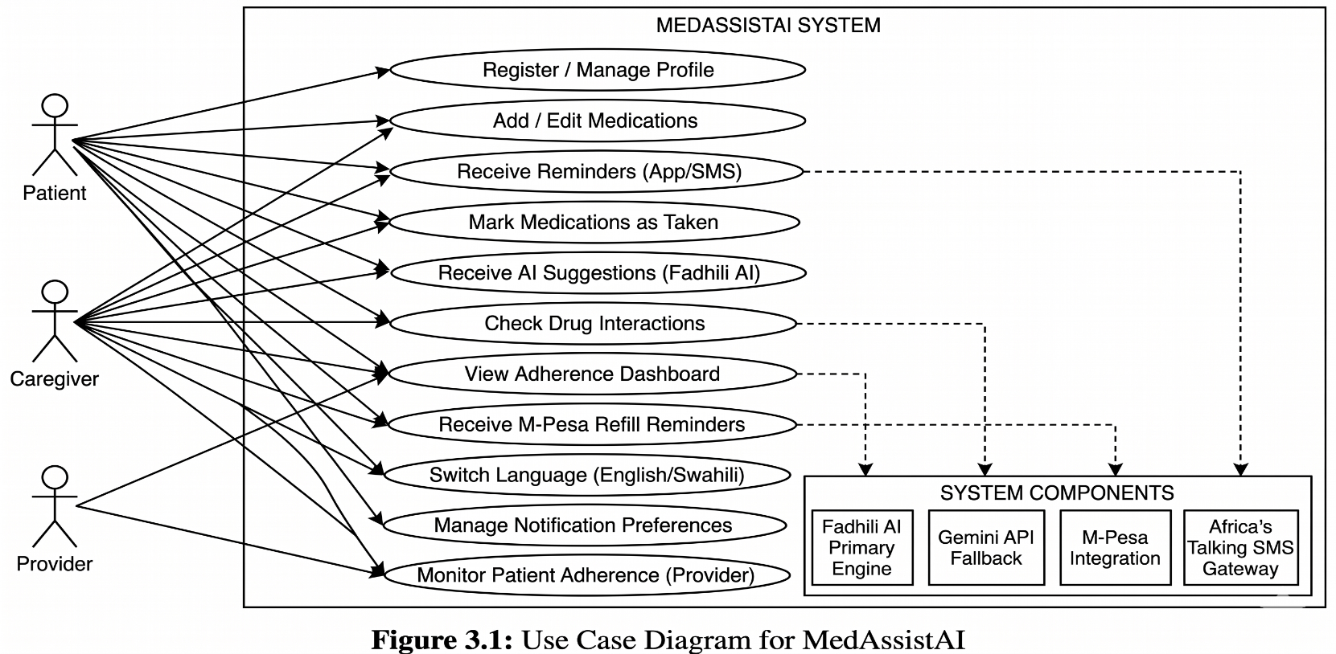
3.7.2 Activity Diagram: How a Medication Reminder Flows
This diagram shows the step-by-step process from setting a reminder to the user receiving it.
text
┌─────────────────────────────────────────────────────────────────┐
│ MEDICATION REMINDER ACTIVITY FLOW │
├─────────────────────────────────────────────────────────────────┤
│ │
│ START → User sets medication schedule │
│ ↓ │
│ System stores in database │
│ ↓ │
│ Reminder time arrives │
│ ↓ │
│ Check: Is Fadhili AI available? │
│ ↓ │
│ If YES → Use Fadhili AI (primary) │
│ If NO → Use Gemini API (fallback) │
│ ↓ │
│ Generate personalized reminder with AI │
│ ↓ │
│ Check: Has user been active in last 24 hours? │
│ ↓ │
│ If YES → Send in-app notification │
│ If NO → Send SMS reminder │
│ ↓ │
│ User receives reminder │
│ ↓ │
│ User marks medication as taken (or not) │
│ ↓ │
│ System logs response and updates adherence stats │
│ ↓ │
│ Fadhili AI learns from this pattern for future │
│ ↓ │
│ END │
│ │
└─────────────────────────────────────────────────────────────────┘

Figure 3.2: Activity Diagram - Medication Reminder Flow
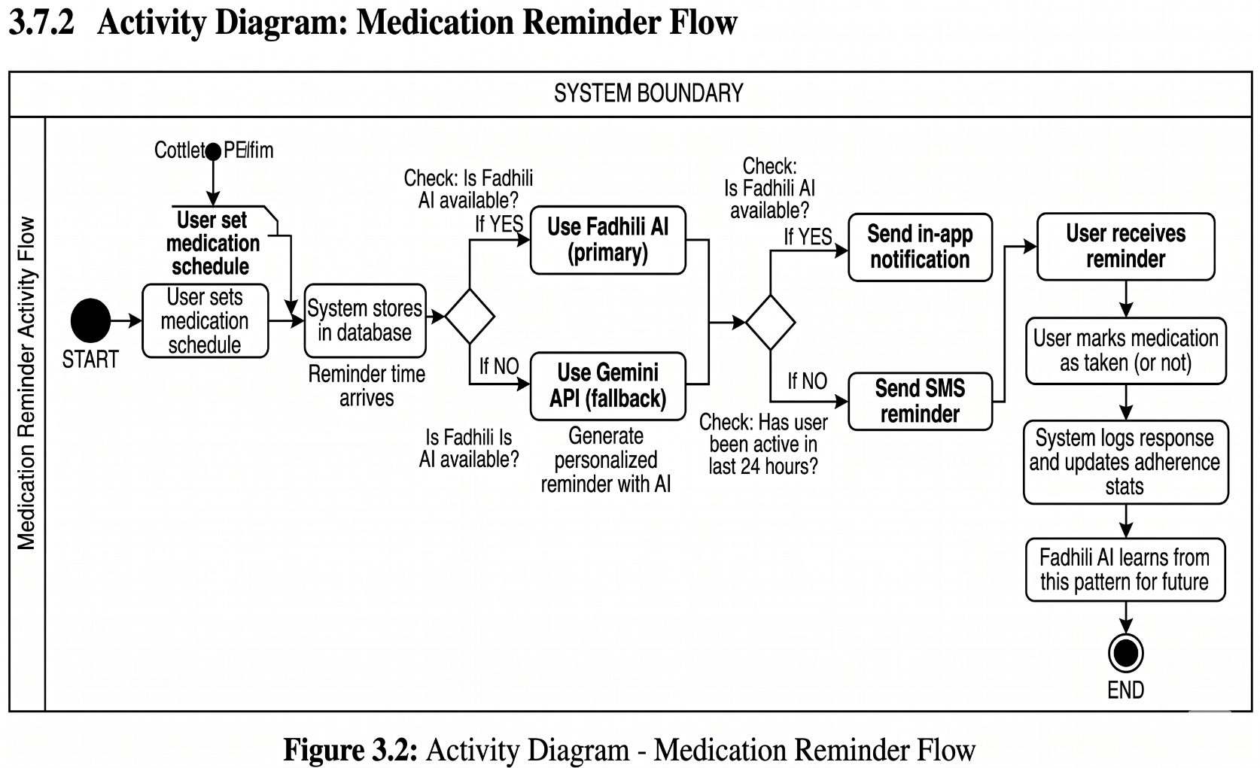
3.7.3 Sequence Diagram: What Happens When the AI Fails
This diagram shows the failover process when Fadhili AI isn't working.
text
User → Frontend → Router → Fadhili AI → Gemini API → Logger

User requests reminder: "When should I take my medicine?"

Router checks Fadhili AI health. Fadhili is working →
Router sends request to Fadhili → Fadhili responds →
User gets response from Fadhili

Later, User makes another request.

Router checks Fadhili AI health again. This time, Fadhili has failed.
Router signals "Fadhili down" and switches to Gemini API.
Router sends request to Gemini → Gemini responds →
Router logs the failover event → User gets response from Gemini (fallback)

User never sees the failure, just a subtle indicator.

Figure 3.3: Sequence Diagram - Dual-AI Failover
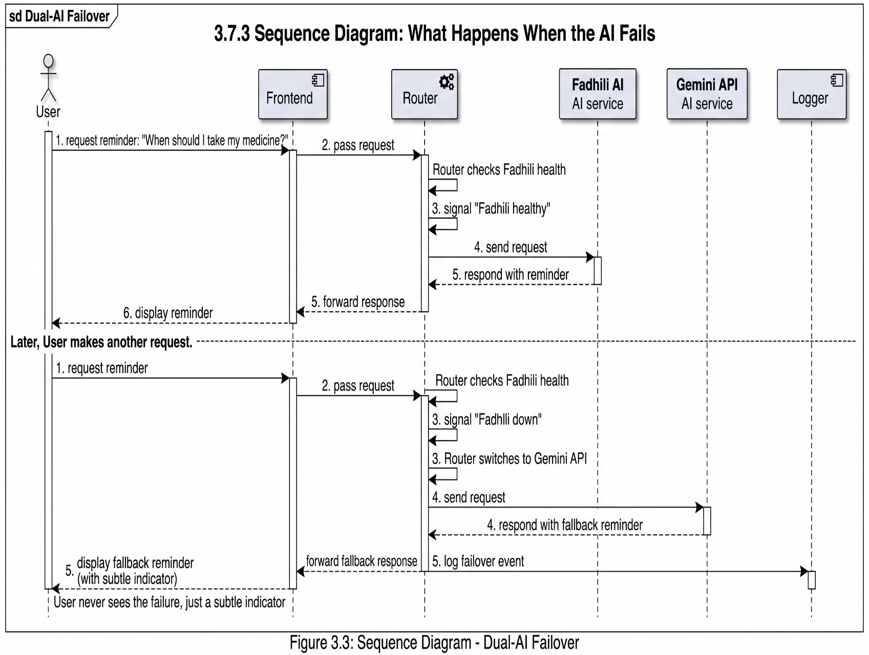
3.7.4 Class Diagram (Conceptual)
This diagram shows the main data structures and how they relate.
text
┌─────────────────────────┐ ┌─────────────────────────┐
│ User │ │ Medication │
├─────────────────────────┤ ├─────────────────────────┤
│ - userId: int │ │ - medId: int │
│ - phoneNumber: string │1 *│ - userId: int │
│ - name: string │─────────│ - name: string │
│ - language: enum │ │ - dosage: string │
│ - conditions: string[] │ │ - frequency: string │
│ - emergencyContact: str │ │ - startDate: date │
└───────────┬─────────────┘ │ - endDate: date │
│ └───────────┬─────────────┘
│ │
▼ │
┌─────────────────────────┐ ┌───────────┴─────────────┐
│ Caregiver │ │ Reminder │
├─────────────────────────┤ ├─────────────────────────┤
│ - caregiverId: int │ │ - reminderId: int │
│ - userId: int │ │ - medId: int │
│ - relationship: string │ │ - scheduledTime: time │
│ - accessLevel: string │ │ - isTaken: boolean │
└─────────────────────────┘ └─────────────────────────┘

┌─────────────────────────┐ ┌─────────────────────────┐
│ AI_Engine │ │ AI_Log │
│ (abstract) │ ├─────────────────────────┤
├─────────────────────────┤ │ - logId: int │
│ + processRequest() │ │ - engineUsed: enum │
│ + checkHealth() │ │ - responseTime: int │
└───────────┬─────────────┘ │ - fallbackOccurred: bool│
│ └─────────────────────────┘
┌─────┴─────┐
▼ ▼
┌─────────────┐ ┌─────────────┐
│ FadhiliAI │ │ GeminiAPI │
├─────────────┤ ├─────────────┤
│ - modelVer │ │ - apiKey │
│ - training │ │ - endpoint │
│ Data │ │ │
└─────────────┘ └─────────────┘

Figure 3.4: Conceptual Class Diagram
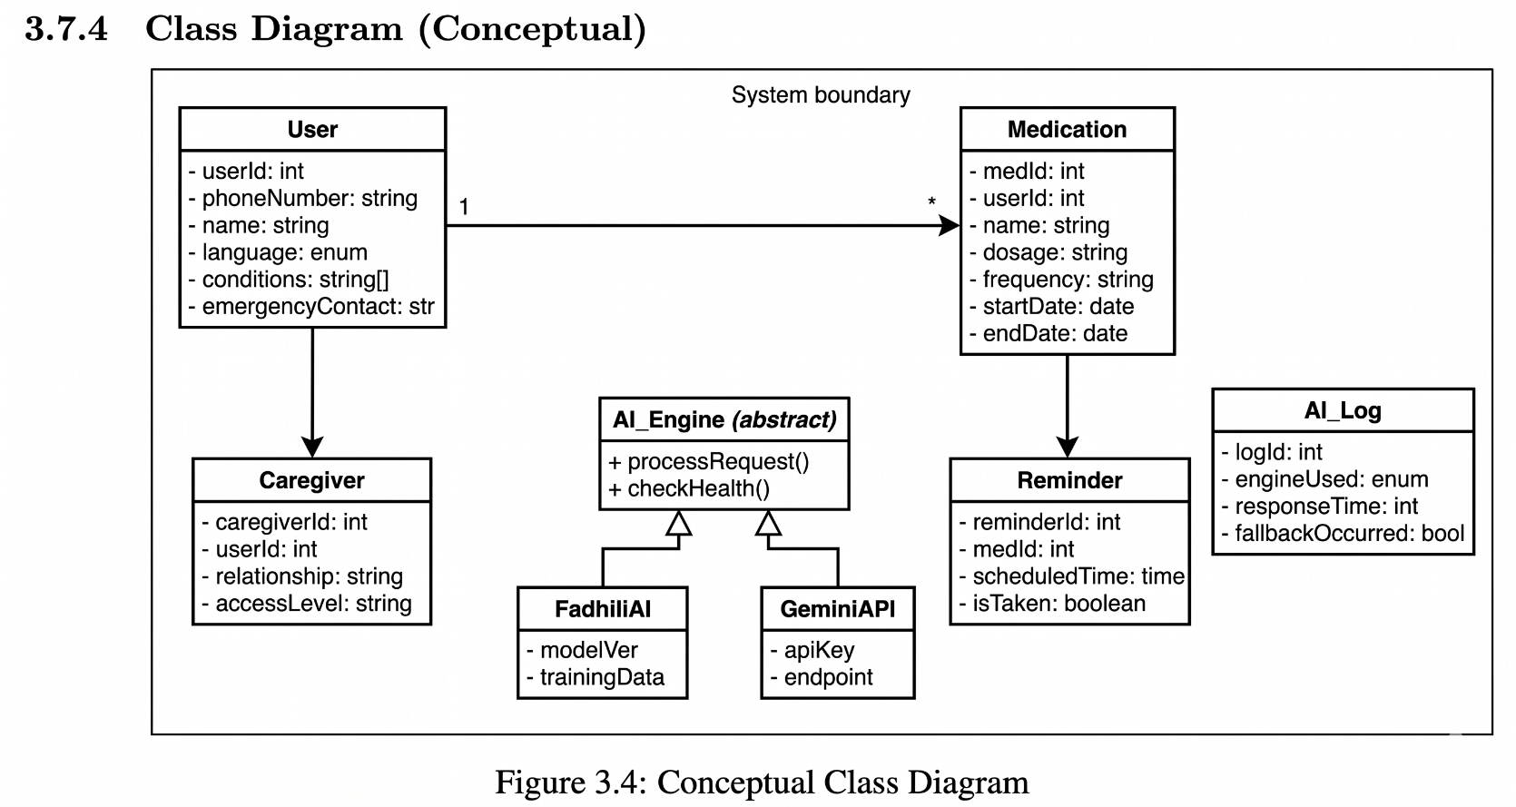
3.8 Logical Design
3.8.1 System Architecture
MedAssistAI uses a three-tier architecture. Think of it like a restaurant: the presentation layer is the dining room (what the customer sees), the application layer is the kitchen (where the work happens), and the data layer is the storage room (where ingredients are kept).
text
┌─────────────────────────────────────────────────────────────────┐
│ PRESENTATION LAYER │
│ (What the user sees and interacts with) │
│ ┌──────────────┐ ┌──────────────┐ ┌──────────────┐ │
│ │ Web App │ │ Mobile Web │ │ SMS UI │ │
│ │ (React.js) │ │ (Responsive)│ │ (USSD/SMS) │ │
│ └──────────────┘ └──────────────┘ └──────────────┘ │
└────────────────────────────┬────────────────────────────────────┘
│
▼
┌─────────────────────────────────────────────────────────────────┐
│ APPLICATION LAYER │
│ (Where the logic and processing happen) │
│ │
│ ┌──────────────────────────────────────────────────────────┐ │
│ │ API Gateway (Node.js/Express) │ │
│ └──────────────────────────────────────────────────────────┘ │
│ │
│ ┌──────────────┐ ┌──────────────┐ ┌──────────────┐ │
│ │ User Service │ │Medication │ │ Reminder │ │
│ │ │ │ Service │ │ Service │ │
│ └──────────────┘ └──────────────┘ └──────────────┘ │
│ │
│ ┌──────────────────────────────────────────────────────────┐ │
│ │ AI ENGINE LAYER │ │
│ │ │ │
│ │ ┌────────────────────────────────────────────────────┐ │ │
│ │ │ AI Router / Orchestrator │ │ │
│ │ │ • Health checks • Load balancing • Failover logic │ │ │
│ │ └──────────────────────┬─────────────────────────────┘ │ │
│ │ │ │ │
│ │ ┌───────────────┴───────────────┐ │ │
│ │ ▼ ▼ │ │
│ │ ┌─────────────────┐ ┌─────────────────┐ │ │
│ │ │ FADHILI AI │ │ GEMINI API │ │ │
│ │ │ (Primary) │◄──────────►│ (Secondary) │ │ │
│ │ │ • Custom model │ Fallback │ • Cloud API │ │ │
│ │ │ • Kenyan data │ Pattern │ • Generic │ │ │
│ │ │ • Swahili │ │ • Reliable │ │ │
│ │ └─────────────────┘ └─────────────────┘ │ │
│ └──────────────────────────────────────────────────────────┘ │
└────────────────────────────┬────────────────────────────────────┘
│
▼
┌─────────────────────────────────────────────────────────────────┐
│ DATA LAYER │
│ (Where information is stored) │
│ ┌──────────────┐ ┌──────────────┐ ┌──────────────┐ │
│ │ PostgreSQL │ │ Redis │ │ File │ │
│ │ (Primary DB)│ │ (Cache) │ │ Storage │ │
│ └──────────────┘ └──────────────┘ └──────────────┘ │
└─────────────────────────────────────────────────────────────────┘

┌─────────────────────────────────────────────────────────────────┐
│ EXTERNAL INTEGRATIONS │
│ ┌──────────────┐ ┌──────────────┐ ┌──────────────┐ │
│ │ M-Pesa API │ │ Africa's │ │ Medical DB │ │
│ │ (Payments) │ │ Talking SMS │ │ (OpenFDA) │ │
│ └──────────────┘ └──────────────┘ └──────────────┘ │
└─────────────────────────────────────────────────────────────────┘

Figure 3.5: System Architecture Diagram
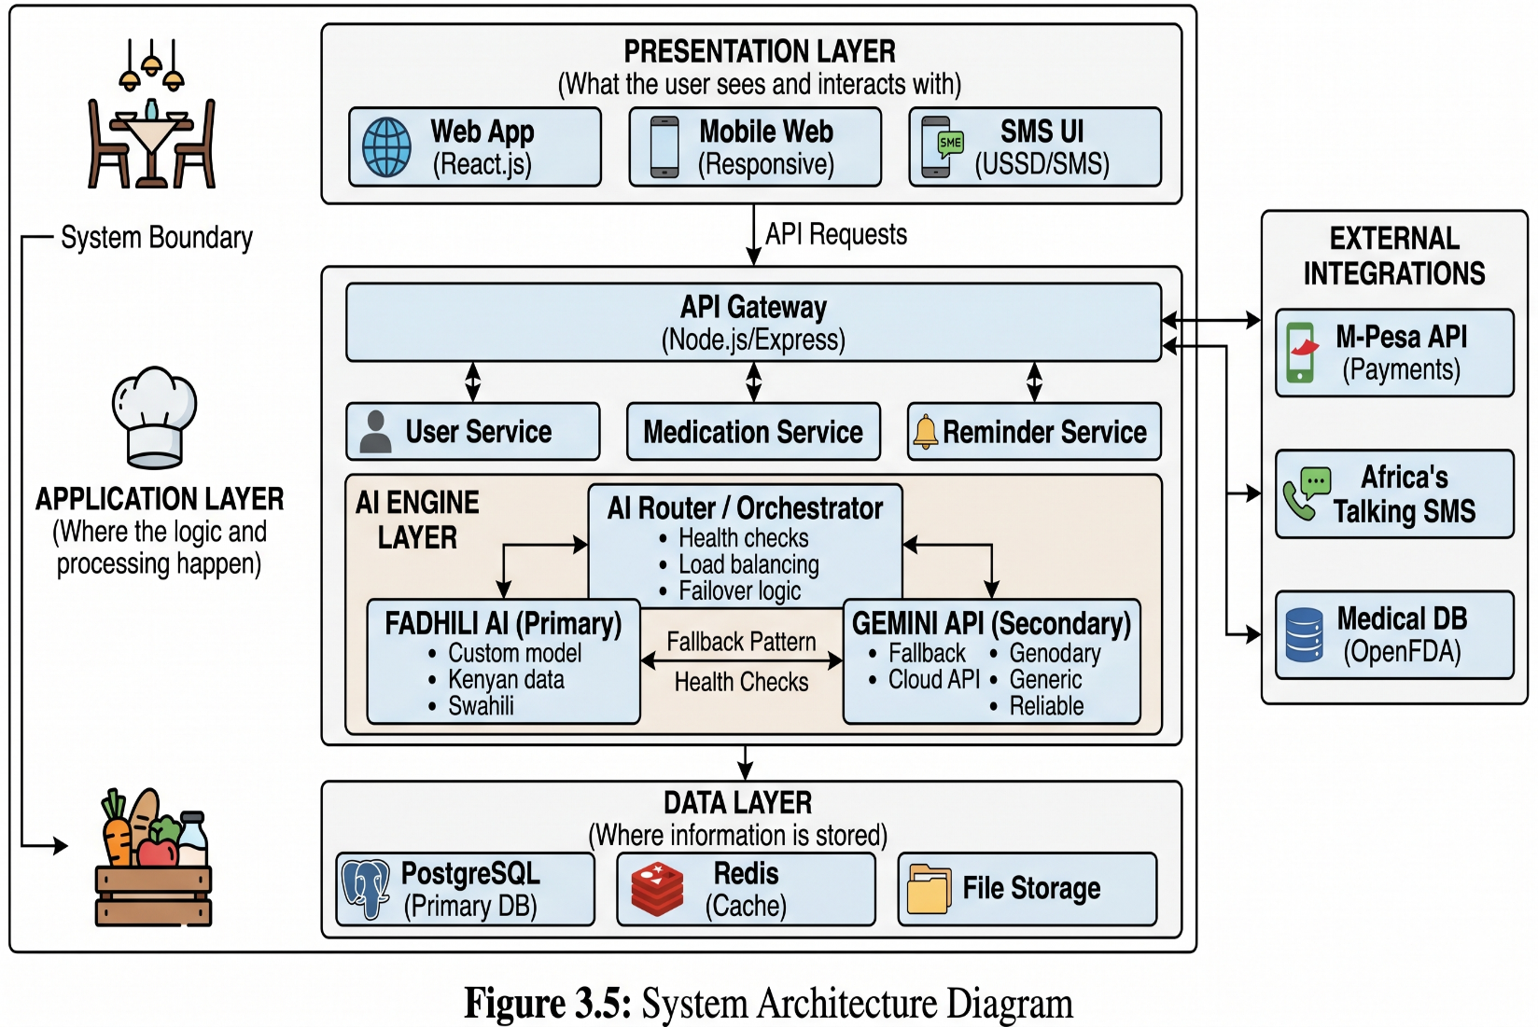
3.8.2 Component Diagram
This diagram shows the major software components and how they talk to each other.
text
┌─────────────────────────────────────────────────────────────────┐
│ CLIENT COMPONENTS │
│ ┌──────────────┐ ┌──────────────┐ ┌──────────────┐ │
│ │ AuthUI │ │ DashboardUI │ │ MedicationUI│ │
│ └──────────────┘ └──────────────┘ └──────────────┘ │
│ │ │ │ │
│ ┌──────┴────────────────────┴────────────────────┴──────┐ │
│ │ React Router │ │
│ └──────────────────────────┬─────────────────────────────┘ │
└──────────────────────────────┼─────────────────────────────────┘
│
▼
┌─────────────────────────────────────────────────────────────────┐
│ BACKEND COMPONENTS │
│ │
│ ┌──────────────────────────────────────────────────────────┐ │
│ │ API Gateway (Express) │ │
│ └──────────────────────────────────────────────────────────┘ │
│ │
│ ┌──────────────┐ ┌──────────────┐ ┌──────────────┐ │
│ │AuthService │ │UserService │ │MedService │ │
│ └──────────────┘ └──────────────┘ └──────────────┘ │
│ ┌──────────────┐ ┌──────────────┐ ┌──────────────┐ │
│ │ReminderService│ │NotifService │ │ReportService │ │
│ └──────────────┘ └──────────────┘ └──────────────┘ │
│ │
│ ┌──────────────────────────────────────────────────────────┐ │
│ │ AI Orchestrator │ │
│ │ HealthMonitor │ FailoverManager │ Router │ │
│ └──────────────────────────────────────────────────────────┘ │
│ │
│ ┌──────────────────────────────────────────────────────────┐ │
│ │ AI Engine Components │ │
│ │ ┌──────────────────────┐ ┌──────────────────────┐ │ │
│ │ │ FadhiliAIComponent │ │ GeminiComponent │ │ │
│ │ │ • ReminderGen │ │ • API Client │ │ │
│ │ │ • InteractionCheck │ │ • ResponseCache │ │ │
│ │ │ • HealthTipGen │ │ • ErrorHandler │ │ │
│ │ └──────────────────────┘ └──────────────────────┘ │ │
│ └──────────────────────────────────────────────────────────┘ │
│ │
│ ┌──────────────┐ ┌──────────────┐ ┌──────────────┐ │
│ │MPesaComponent│ │SMSComponent │ │MedicalDBComp │ │
│ └──────────────┘ └──────────────┘ └──────────────┘ │
└─────────────────────────────────────────────────────────────────┘
│
▼
┌─────────────────────────────────────────────────────────────────┐
│ DATA COMPONENTS │
│ ┌──────────────┐ ┌──────────────┐ ┌──────────────┐ │
│ │ UserDAO │ │ MedDAO │ │ LogDAO │ │
│ └──────────────┘ └──────────────┘ └──────────────┘ │
│ │ │ │ │
│ ┌──────┴────────────────────┴────────────────────┴──────┐ │
│ │ PostgreSQL Database │ │
│ └─────────────────────────────────────────────────────────┘ │
└─────────────────────────────────────────────────────────────────┘

Figure 3.6: Component Diagram
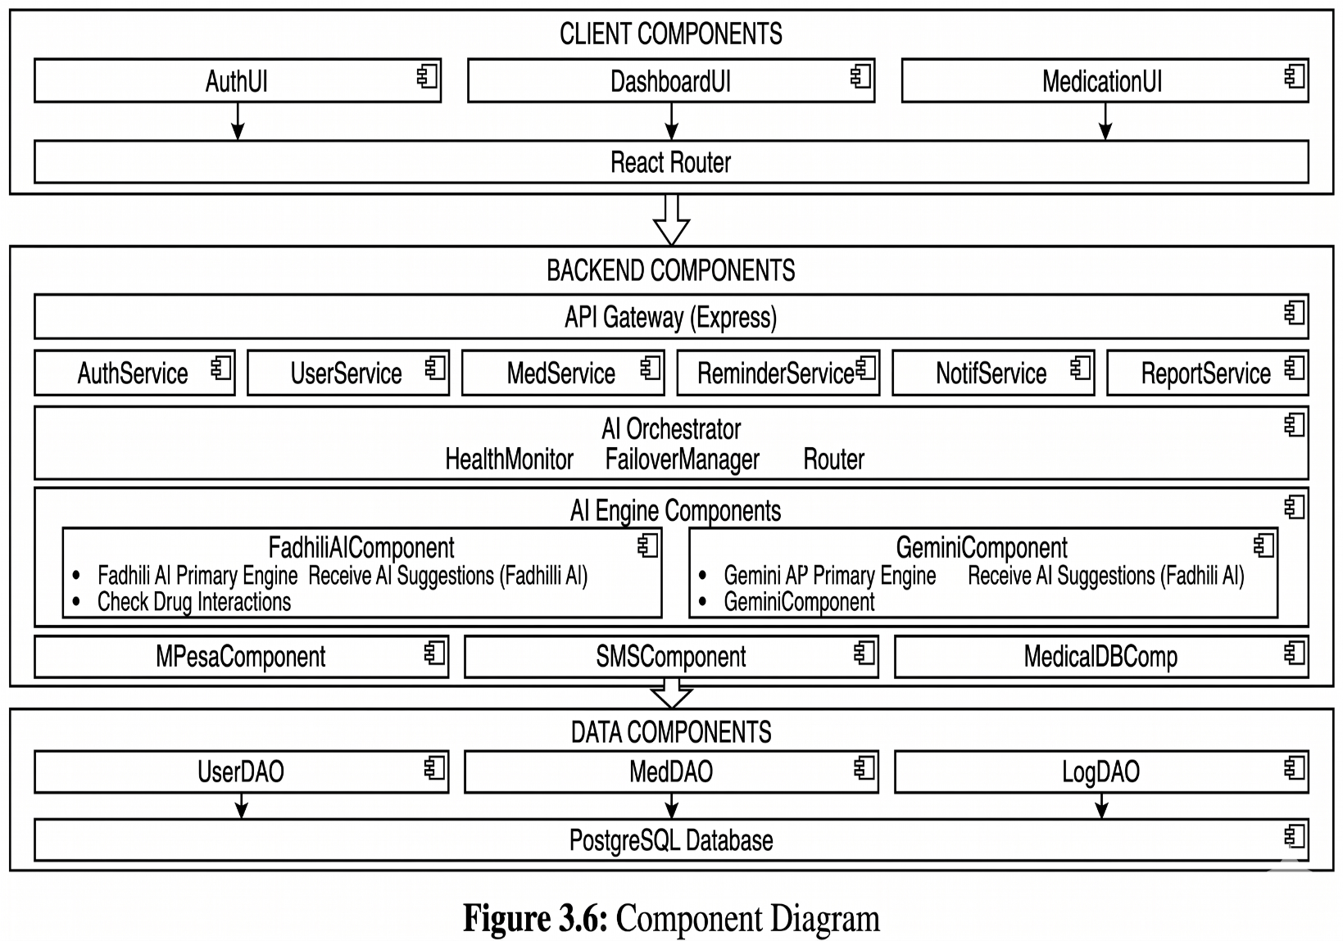
3.8.3 Control Flow and Process Design
3.8.3.1 User Registration Process
Here's what happens step by step when someone signs up:
text
START
↓
User visits registration page
↓
User selects language (English or Swahili)
↓
System displays form in selected language
↓
User enters: phone number, name, conditions, emergency contact
↓
System validates input
↓
If invalid → Show error message, try again
If valid → Check if phone number already registered
↓
If already registered → Prompt login or password reset
If new → Generate PIN and send via SMS
↓
User enters PIN received on their phone
↓
If PIN wrong → Show error, allow retry (max 3 attempts)
If PIN correct → Create user account in database
↓
Show welcome message (personalized by Fadhili AI)
↓
Redirect to dashboard
↓
END

Figure 3.7: User Registration Flowchart
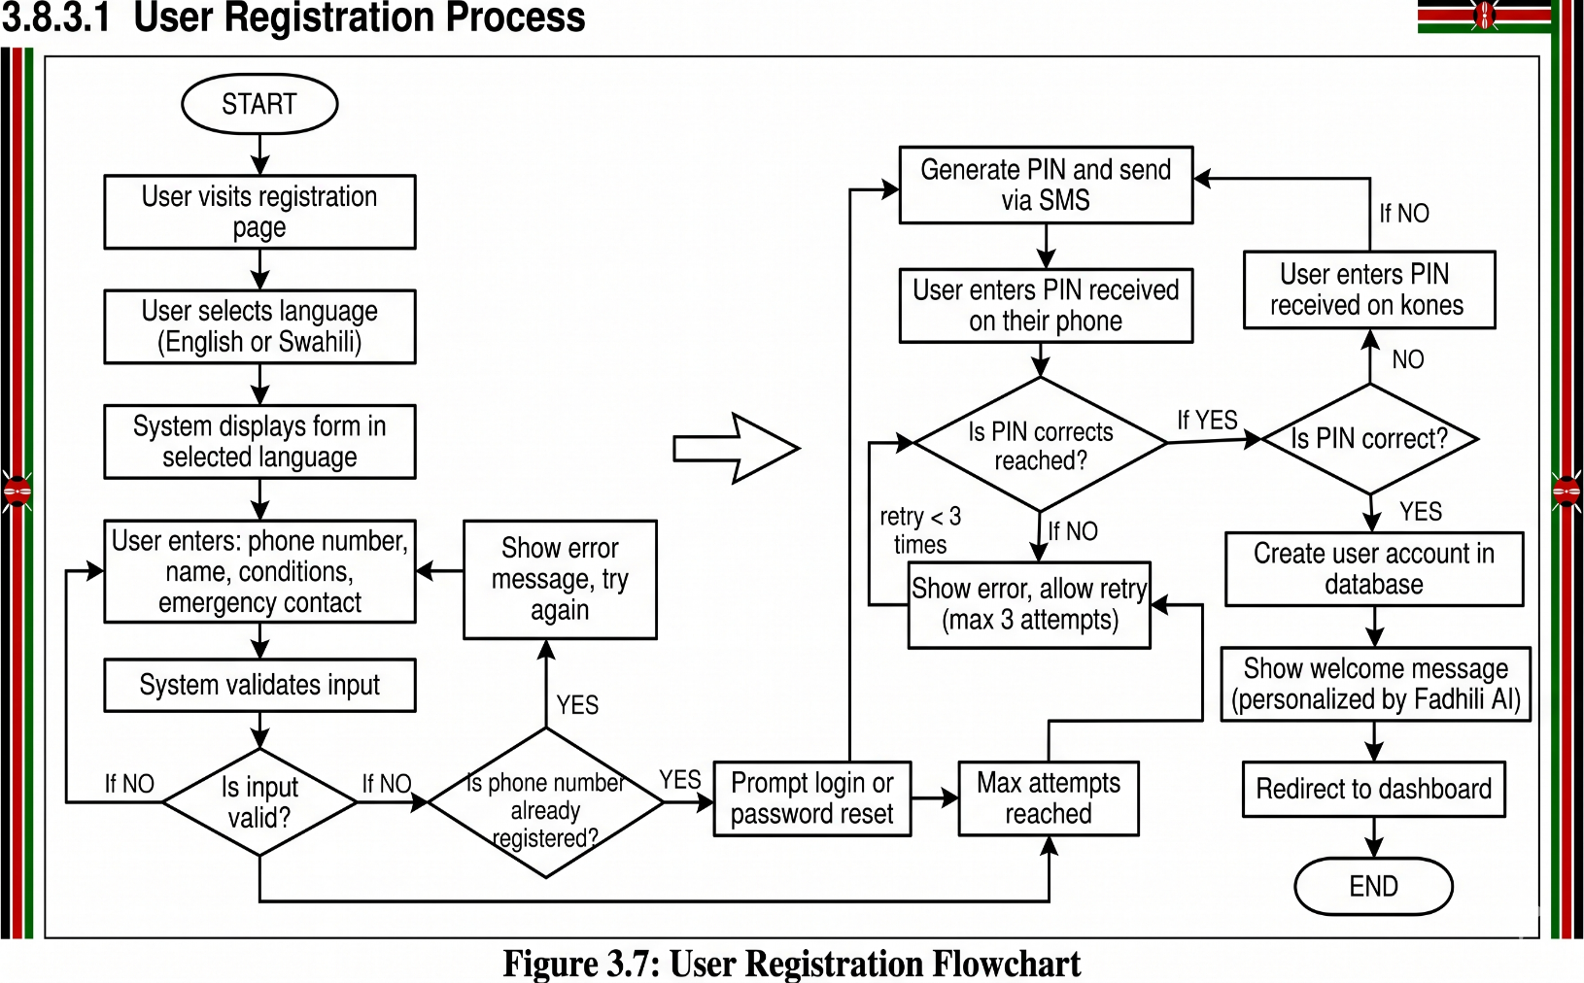
3.8.3.2 Adding a New Medication (Pseudocode)
Here's the logic for when a user adds a new medication to their list:
text
PROCEDURE AddMedication(userId, medicationData)

// Step 1: Make sure the data is valid
IF medicationData.name is empty THEN
RETURN error("Medication name is required")
END IF

IF medicationData.dosage is empty THEN
RETURN error("Dosage information is required")
END IF

// Step 2: Check for drug interactions
TRY
// Try Fadhili AI first
interactions = fadhiliAI.CheckDrugInteractions(
userId = userId,
newMedication = medicationData.name,
existingMeds = GetUserMedications(userId)
)
CATCH
// If Fadhili fails, fall back to Gemini
LogEvent("Fadhili AI failed, using Gemini for interaction check")
interactions = geminiAPI.CheckDrugInteractions(
newMedication = medicationData.name,
existingMeds = GetUserMedications(userId)
)
END TRY

// Step 3: If serious interaction found, warn the user
IF interactions.severity = "high" THEN
DisplayWarning("Serious interaction detected: " + interactions.description)
IF user does not confirm THEN
RETURN cancel("Medication not added due to interaction risk")
END IF
END IF

// Step 4: Save medication to database
medId = Database.SaveMedication(userId, medicationData)

// Step 5: Create reminder schedule based on frequency
reminders = GenerateReminderSchedule(medId, medicationData.frequency)

// Step 6: Save reminders
FOR EACH reminder IN reminders
Database.SaveReminder(reminder)
END FOR

// Step 7: Generate personalized tips using AI (optional)
TRY
tips = fadhiliAI.GenerateReminderTips(medicationData)
SaveTips(userId, medId, tips)
CATCH
// If this fails, it's not critical. Just log and continue.
LogEvent("Could not generate tips")
END TRY

RETURN success("Medication added successfully")

END PROCEDURE
8.3.3.3 Daily Reminder Processing
Every minute, a scheduled job runs to check which reminders need to be sent:
text
Every minute:
↓
Query database for reminders due in the next minute
↓
For each due reminder:
↓
Get user preferences and last activity time
↓
Decision: Which channel to use?
IF user active in last 24 hours:
channel = "IN_APP"
ELSE:
channel = "SMS"
↓
Prepare reminder content using AI
↓
TRY:
Use Fadhili AI to generate personalized message
CATCH:
Log that Fadhili failed, use Gemini instead
↓
Generate message in user's preferred language (English/Swahili)
↓
Send notification via chosen channel
↓
Log that reminder was sent
↓
Wait 30 minutes
↓
If user hasn't marked as taken, send gentle reminder via SMS

Figure 3.8: Daily Reminder Processing Flow
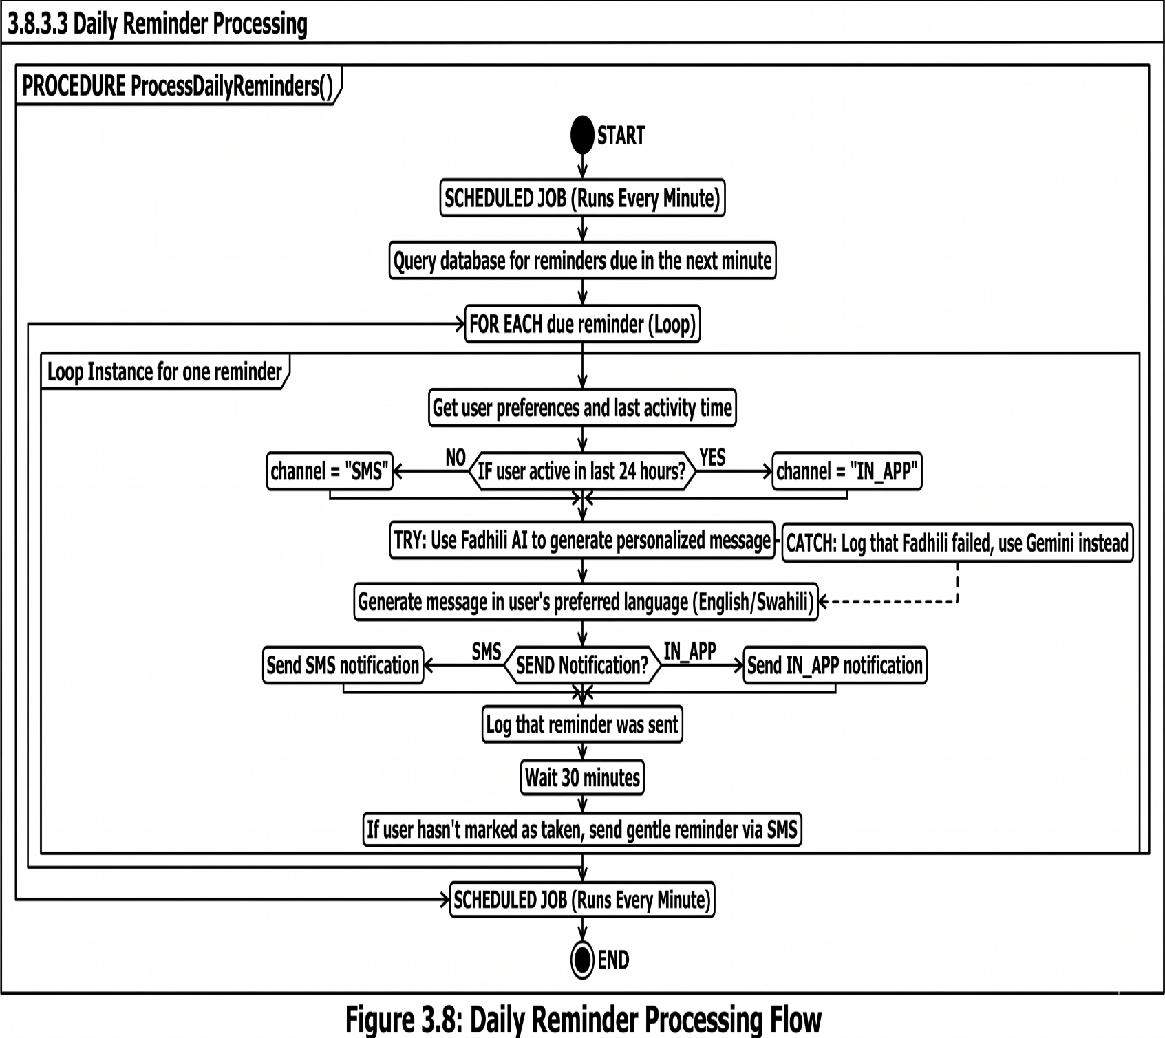

3.8.4 State Chart Diagrams
User Session States:
text
┌─────────────┐
│ Logged Out │
└──────┬──────┘
│ Login
▼
┌─────────────┐
┌────>│ Active │────┐
│ │ Session │ │
│ └──────┬──────┘ │ Inactivity > 15min
│ │ │
│ ┌──────▼──────┐ │
│ │ Idle │<───┘
│ │ (5-15 min) │
│ └──────┬──────┘
│ │ Activity
└────────────┘
│
┌──────▼──────┐
│ Logout │
└─────────────┘

Figure 3.9: User Session State Diagram
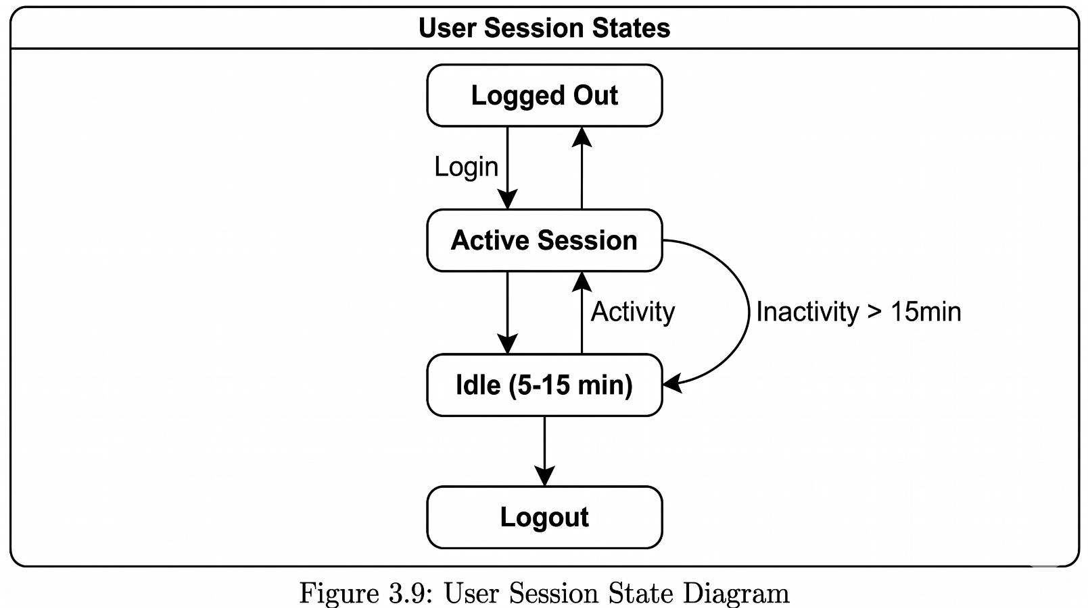
AI Engine States:
text
┌─────────────┐
│ FADHILI │
│ AI │
│ (Primary) │
└──────┬──────┘
│
┌──────────────┼──────────────┐
▼ ▼ ▼
┌─────────────┐ ┌─────────────┐ ┌─────────────┐
│ Active │ │ Degraded │ │ Failed │
│ (OK) │ │ (Slow) │ │ │
└─────────────┘ └─────────────┘ └──────┬──────┘
│ │ │
└──────────────┼──────────────┘
▼
┌─────────────────────┐
│ TRIGGER FAILOVER │
│ Switch to Gemini │
└──────────┬──────────┘
▼
┌─────────────────────┐
│ GEMINI ACTIVE │
│ (Fallback Mode) │
└──────────┬──────────┘
│
┌──────────▼──────────┐
│ Monitor Fadhili AI │
│ for recovery │
└──────────┬──────────┘
│
┌──────────▼──────────┐
│ Fadhili Recovered? │──No──┐
└──────────┬──────────┘ │
│ Yes │
▼ │
┌─────────────────────┐ │
│ Switch back to │ │
│ Fadhili AI (Primary)│ │
└─────────────────────┘ │
│ │
└──────────────────┘

Figure 3.10: AI Engine State Diagram
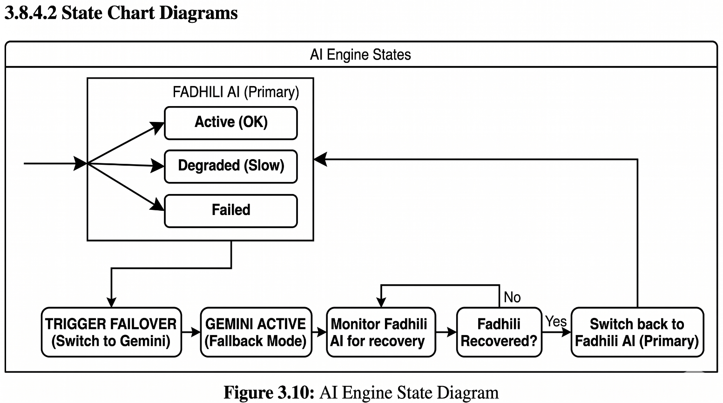
3.8.5 Design for Non-Functional Requirements
3.8.5.1 Security Design
I'm building security in from the ground up to comply with Kenya's Data Protection Act (2019).
Security Layer | How I'm Implementing It
Authentication | Phone number + 6-digit PIN, session tokens
Authorization | Role-based access (patient, caregiver, provider)
Data Encryption | AES-256 for stored data, TLS 1.3 for data in transit
Input Validation | All user inputs checked and cleaned on the server
Audit Logging | Every data access is logged with timestamp and user ID
Data Minimization | I only collect what I absolutely need
Consent Management | Clear opt-in, users can withdraw anytime
Here's a simplified version of the authentication logic:
text
FUNCTION authenticateUser(request)
token = request.headers.authorization

IF token is missing THEN
RETURN error("Please log in first")
END IF

session = redisClient.get("session:" + token)

IF session is expired or invalid THEN
RETURN error("Your session has expired. Please log in again.")
END IF

request.userId = session.userId
request.userRole = session.role

CONTINUE to the requested action
END FUNCTION
3.8.5.2 Error and Exception Handling Strategy
Things will go wrong. I need to handle that gracefully.
Error Type | Examples | How I'll Handle It
User Input Errors | Wrong phone number format, missing fields | Clear error messages in user's language, highlight the problem field
Authentication Errors | Wrong PIN, expired session | Allow 3 attempts, then lock temporarily. Clear instructions to reset
Database Errors | Connection failed, query timeout | Retry automatically (up to 3 times), log error, notify me if persistent
AI Engine Errors | Fadhili AI unavailable | Automatic failover to Gemini, log the incident
API Integration Errors | M-Pesa down, SMS gateway slow | Queue messages, retry later, tell user there's a delay
Network Errors | User goes offline | Cache data locally, sync when connection returns
Here's how the AI failover works in code:
text
FUNCTION handleAIRequest(userId, query, context)
MAX_RETRIES = 3

FOR attempt = 1 TO MAX_RETRIES
TRY
// Try Fadhili AI first
response = fadhiliAI.process(query, context)
logAIUsage(userId, "fadhili", "success")
RETURN { source: "fadhili", data: response }

CATCH error
LogEvent("Fadhili AI attempt " + attempt + " failed")

IF attempt < MAX_RETRIES THEN
Wait(1 second × attempt) // Wait longer each time
CONTINUE // Try again
ELSE
// All retries failed, fall back to Gemini
LogEvent("Falling back to Gemini")

TRY
fallbackResponse = geminiAPI.process(query, context)
logAIUsage(userId, "gemini", "fallback")
RETURN { source: "gemini", data: fallbackResponse }

CATCH geminiError
// Both AIs failed - critical error
LogCriticalError("Both AI engines failed")
// Return a simple rule-based response as last resort
RETURN { source: "rule-based", data: generateBasicReminder() }
END TRY
END IF
END TRY
END FOR
END FUNCTION
3.8.5.3 Performance Optimization
Strategy | How I'll Do It | Expected Benefit
Caching | Store frequent queries and AI responses in Redis | 50% faster response times
Database Indexing | Index on user_id, reminder_time, status columns | Faster searches
Connection Pooling | Reuse database connections instead of opening new ones | Less overhead
Lazy Loading | Only load data when it's actually needed | Faster initial page load
Image Optimization | Compress images, use modern formats | Less data usage for users
Query Optimization | Write efficient SQL, use prepared statements | Faster database access
3.8.5.4 Usability Design Principles
From talking to users, I learned that simplicity is everything. Here are my guiding principles:
- Keep it simple. Big buttons, clear labels, no clutter.
- Low literacy? No problem. Icons next to text, voice prompts for critical things.
- Language choice matters. The Swahili/English toggle is prominent on every screen, not buried in settings.
- Be forgiving. Confirm before deleting anything. Offer undo when possible.
- Consistent navigation. Same patterns throughout. No surprises.
- Give feedback. When someone does something, they should know it worked. Show loading indicators for slow operations.
- Accessibility by default. High contrast, text can be resized, works with screen readers.
- Work offline. Clear indicators when offline, actions queued to sync later.
3.9 Physical Design
3.9.1 Database Design
I'm using MongoDB as my database. Unlike traditional relational databases (like MySQL or PostgreSQL) that store data in rigid tables with fixed columns, MongoDB stores data as flexible documents in JSON-like format. This is a perfect fit for MedAssistAI for several reasons:
Why MongoDB fits this project:
- Flexible schema. Different patients have different conditions, medications, and data needs. With MongoDB, I don't need to force everyone into the same rigid table structure. Each patient document can have exactly the fields they need.
- Natural JavaScript fit. My entire stack is JavaScript (Node.js backend, React frontend). MongoDB speaks JSON natively. No awkward translation between database tables and JavaScript objects.
- Easy to change. As I learn what users actually need, I can add new fields without running complex database migrations.
- Good for varied data. Medication schedules, reminders, and logs all have different structures. MongoDB handles this naturally.
- Scales well. If MedAssistAI grows to thousands of users, MongoDB can handle it.
What the database looks like (Collections instead of Tables):
In MongoDB, data is organized into collections (similar to tables in SQL) and documents (similar to rows). Here's how I've structured the data:

Collection 1: users
Each patient or user is a document with this structure:
{
"_id": ObjectId("65f1a2b3c4d5e6f7a8b9c0d1"),
"phoneNumber": "+254712345678",
"fullName": "Jane Wanjiku",
"pinHash": "$2b$10$encrypted_hash_here",
"language": "sw",
"conditions": ["hypertension", "diabetes"],
"emergencyContact": "+254798765432",
"createdAt": ISODate("2025-01-15T10:30:00Z"),
"lastActive": ISODate("2025-03-01T08:15:00Z"),
"dataConsent": true,
"role": "patient"
}
What each field means:
- _id: Unique identifier (MongoDB generates this automatically)
- phoneNumber: User's phone number (used for login and SMS)
- fullName: User's name
- pinHash: Securely hashed PIN (never stored as plain text)
- language: 'en' for English, 'sw' for Swahili
- conditions: Array of chronic conditions (flexible—can have 1 or many)
- emergencyContact: Phone number of someone to notify
- createdAt: When they registered
- lastActive: Last time they used the app
- dataConsent: Whether they agreed to privacy terms (Data Protection Act)
- role: 'patient', 'caregiver', or 'provider'

Collection 2: medications
Each medication a patient takes is a document:
json
{
"_id": ObjectId("65f1a2b3c4d5e6f7a8b9c0d2"),
"userId": ObjectId("65f1a2b3c4d5e6f7a8b9c0d1"),
"name": "Metformin",
"dosage": "500mg",
"frequency": "twice_daily",
"times": ["08:00", "20:00"],
"startDate": ISODate("2025-01-20"),
"endDate": null,
"conditionTreated": "diabetes",
"active": true,
"instructions": "Take with food",
"refillReminder": true
}
Key points:
- userId links to the patient in the users collection
- times is an array (supports multiple times per day naturally)
- endDate can be null for ongoing medications
- instructions stores personalized notes from AI

Collection 3: reminders
Each scheduled reminder (generated from medications):
json
{
"_id": ObjectId("65f1a2b3c4d5e6f7a8b9c0d3"),
"medicationId": ObjectId("65f1a2b3c4d5e6f7a8b9c0d2"),
"userId": ObjectId("65f1a2b3c4d5e6f7a8b9c0d1"),
"scheduledTime": ISODate("2025-03-02T08:00:00Z"),
"isTaken": false,
"takenTime": null,
"reminderMethod": "both",
"aiSource": "fadhili",
"message": "Time to take Metformin 500mg. Take with breakfast for best results.",
"sentAt": ISODate("2025-03-02T08:00:00Z")
}

Collection 4: health_logs
Daily adherence summary for each patient:
json
{
"_id": ObjectId("65f1a2b3c4d5e6f7a8b9c0d4"),
"userId": ObjectId("65f1a2b3c4d5e6f7a8b9c0d1"),
"date": ISODate("2025-03-01"),
"adherenceRate": 85.5,
"medicationsTaken": 6,
"medicationsMissed": 1,
"totalScheduled": 7,
"notes": "Missed evening dose due to being away from home"
}

Collection 5: ai_logs
Tracks which AI engine handled each request (for monitoring failover):
json
{
"_id": ObjectId("65f1a2b3c4d5e6f7a8b9c0d5"),
"userId": ObjectId("65f1a2b3c4d5e6f7a8b9c0d1"),
"requestId": "req_abc123",
"queryType": "reminder",
"engineUsed": "fadhili",
"responseTimeMs": 1250,
"fallbackOccurred": false,
"timestamp": ISODate("2025-03-01T08:00:00Z")
}

Collection 6: notifications
Records of all notifications sent:
json
{
"_id": ObjectId("65f1a2b3c4d5e6f7a8b9c0d6"),
"userId": ObjectId("65f1a2b3c4d5e6f7a8b9c0d1"),
"type": "reminder",
"channel": "sms",
"content": "Time to take your blood pressure medication",
"sentAt": ISODate("2025-03-01T08:00:00Z"),
"delivered": true,
"deliveryStatus": "sent"
}
Indexes (for faster queries):
Just like in SQL, MongoDB needs indexes to make queries fast:
javascript
// Create indexes for common queries
db.users.createIndex({ phoneNumber: 1 }) // For login by phone
db.medications.createIndex({ userId: 1 }) // For finding a user's meds
db.reminders.createIndex({ scheduledTime: 1 }) // For finding due reminders
db.reminders.createIndex({ userId: 1, isTaken: 1 }) // For adherence stats
db.ai_logs.createIndex({ timestamp: -1 }) // For recent logs
Figure 3.11: MongoDB Data Model Diagram
text
┌─────────────────────────────────────────────────────────────────┐
│ MONGODB COLLECTIONS │
│ │
│ ┌─────────────────────────────────────────────────────────┐ │
│ │ users │ │
│ │ { _id, phoneNumber, fullName, pinHash, language, │ │
│ │ conditions[], emergencyContact, createdAt, │ │
│ │ lastActive, dataConsent, role } │ │
│ └───────────────────────────┬─────────────────────────────┘ │
│ │ │
│ ┌───────────────┼───────────────┐ │
│ ▼ ▼ ▼ │
│ ┌───────────────┐ ┌───────────────┐ ┌───────────────┐ │
│ │ medications │ │ health_logs │ │ notifications │ │
│ │ { _id, │ │ { _id, │ │ { _id, │ │
│ │ userId, │ │ userId, │ │ userId, │ │
│ │ name, │ │ date, │ │ type, │ │
│ │ dosage, │ │ adherence- │ │ channel, │ │
│ │ frequency, │ │ Rate, │ │ content, │ │
│ │ times[], │ │ notes } │ │ sentAt } │ │
│ │ active } │ └───────────────┘ └───────────────┘ │
│ └───────┬───────┘ │
│ │ │
│ ▼ │
│ ┌───────────────┐ ┌───────────────┐ │
│ │ reminders │ │ ai_logs │ │
│ │ { _id, │ │ { _id, │ │
│ │ medication-│ │ userId, │ │
│ │ Id, │ │ requestId, │ │
│ │ userId, │ │ engineUsed,│ │
│ │ scheduled- │ │ response- │ │
│ │ Time, │ │ TimeMs, │ │
│ │ isTaken, │ │ fallback- │ │
│ │ message } │ │ Occurred } │ │
│ └───────────────┘ └───────────────┘ │
│ │
│ Relationships (references, not foreign keys): │
│ • medications.userId → users._id │
│ • reminders.userId → users._id │
│ • reminders.medicationId → medications._id │
│ • health_logs.userId → users._id │
│ • ai_logs.userId → users._id │
│ │
└─────────────────────────────────────────────────────────────────┘

Figure 3.11: MongoDB Collection Structure Diagram
Note: In MongoDB, these are "soft references" (application-level links), not database-enforced foreign keys. I handle referential integrity in my application code.

